**Q1. What is JQuery?**

Ans. Query is a lightweight, "write less, do more", JavaScript library.

The purpose of jQuery is to make it much easier to use JavaScript on your website.

jQuery takes a lot of common tasks that require many lines of JavaScript code to accomplish, and wraps them into methods that you can call with a single line of code.

jQuery also simplifies a lot of the complicated things from JavaScript, like AJAX calls and DOM manipulation.

The jQuery library contains the following features:

* HTML/DOM manipulation
* CSS manipulation
* HTML event methods
* Effects and animations
* AJAX
* Utilities

**Q2. Explain any 3 features of JQuery?**

Ans. Jquery is the Library of JavaScript. It is simple and easy to learn. For perform any task Jquery required less code compare to javascript.

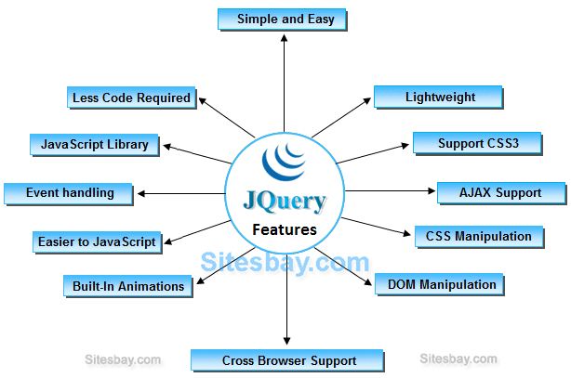

* **Selecting and Filtering:**

To make a selection DOM(Document object model), jQuery has a selector engine. There are various methods that jQuery has, which allows it to work with a selection to control the elements you are working with from the DOM. Some methods let you select different elements present in the code. They are the parent elements, sibling elements, ancestor elements, and descendant elements. You can remove elements from the selection, add elements to a selection and also reduce a selection to a specific subset of elements.

* **Event wrapper methods:**

jQuery offers a comprehensive and powerful event API. Its event API provides wrapper methods that contain most of the events in JavaScript. It also provides the capability to attach events that it doesn’t explicitly support through its event methods. The jQuery event API even has the capability to apply events to elements that might not even exist in the document yet. In jQuery events can be organized neatly and the names spaced within it. You can organize these events neatly into named categories; this, therefore, makes it a lot easier to manage the events. It is also easier to remove the specific events also.

* **Manipulating Content and Attributes:**

Working with attributes is quite easy in jQuery. The first thing you need to do is make a selection after you’ve made a selection; you can do something with your selection like you can set the attributes and access the attributes. Setting the attributes on a selection sets those attributes on every element that you’ve selected. The DOM content can be shuffled around and things like replacing one element with another, inserting new text or even HTML into the tags of HTML, appending or prepending the contents, clinging the content and removing the contents that need to be gotten rid of. You can manipulate the attributes using jQuery. It does so by providing all the methods that are needed, which is already available in the library. Maybe there’s a necessity to save custom data with an element; well, jQuery has answers for that.

* **Ajax and jQuery:**

Ajax stands for Asynchronous JavaScript and XML. It loads data in the background and displays the result on the page without the need of reloading the entire page. jQuery does provide a lot of methods for Ajax’s functionality. With the help of these Ajax methods, you can request HTML, request a text, or an XML file or even JSON. These can be requested from a remote server using the HTTP methods. They are the HTTP GET and the HTTP Post methods. By doing so, you can load the entire data into the specific HTML elements of the page.

* **jQuery and Animation:**

There are jQuery methods that provide animation to elements like showing and hiding the elements through different ways like fading in, fading out, sliding in, sliding out. This can be done by defining the CSS properties that need to be animated. Elements can move up and down, using custom animation. It also provides a variety of easing effects that can be used to control the flow time in animation.

* **jQuery and CSS:**

The term ‘CSS’ refers to cascading style sheets. They are mainly used for styling the elements that are present on the web page. It has control over how the layout is viewed by the end-user, and it also differs depending upon the device through which the user sees the webpage. jQuery has methods that are both versatile as well as intuitive that help you to change, add, remove the styles that are being present in the elements in the HTML file.